**PROBLEM STATEMENT**

Consider yourself a Final year Engineering student, who will be passing out in July 2019. Year 2018 was a bad year in terms of job or job market, with the global slow down and recession the prospect of a 5 figure Salary Cheque is a mirage for the students passing out in year 2019.  Your college authorities with the help of your college alumni association has lined up few off-campus placement drives, but none of them will give the amount of salary you were looking for in the year 2019.

Meantime in your summer break some of you joined a networking course in IPEC Ghaziabad offered by Netcamp Solutions Private Limited Company. The course was for 21 days. The basic idea for joining the course was going away from the mad – mad world for 21 days.

Though the idea was FUN and MASTI, you liked the course and learned how to setup a network infrastructure which can be a basic platform for any e-Business.

After completing the course you decided, enough is enough no more searching for jobs, you will start your own company which will provide e-Business and e-Service solutions to the various small companies across the Country.

On a last day of the training program, during your tea break (in the mess ) you proposed your idea to all of your group members of your group. You were overwhelmed with the support and their willingness to join your new venture. All wanted to leave their own mark – idea was to be a “JOB Maker – Not a JOB Seeker”.

You all decided to start, the company name will be the group name that you had in Netcamp. You decided to start the web services first so you can display your product lines on the web as well as communicate with your future customers.

The Owner of Netcamp was very happy with your initiation, he agreed to give you a loan of Rs. 10,00,000/- (Rupees ten lac only) as your starting capital. Infact , he was so happy that some of his students are willing to take the path which he has taken some 5 years before, he gave the loan at meager 4% annual interest (where the business loan is anything about 9% + from any reputed bank in India)

You bought the following items to start your Company and plan to inaugurate the portal by 9am 1st October 2019. (very little time left – but you are motivated to go ahead and – confident you will be ready by then)

a)      Rented a space to use it as office and keep your servers

b)      3 Red Hat Linux Enterprise server. With plenty of memory and storage space

c)      3 live IP address

d)      32Mbps internet connection from reliance

e)      A domain name as netcamp.in

After a group meeting you decided to do the following and get it going.

* Create one web server which will host all the web sites for the Company (netcamp.in)
* Create one DNS server .
* Create one mailing server which will provide the email service for the Institution / Company (mail.netcamp.in – and should be able to access from web). Mail server should have POP3 support so user can download email in their own laptop/desktop. (Please customize the mail page with your own company logo and company name)
* The mail server will be the file server which will have file storage space for the user.
* File server will also have a dhcp server (range of ip’s =192.168.1.150 to 192.168.1.190 gateway=192.168.1.1 and dns server = give your dns server) so that it can give ip address to all client machines.
* You were 4/5 in your group you decided that  you will be the Chairman of the company and will have access to all the files / folders in your company. You created three departments – Sales, R&D and Accounts. Please divide the group members in all these groups. For the file management you decided about the following points.

Email address

[username@netcamp.in](mailto:username@company.in)

company.in (should also open as www.netcamp.in)

sales.company.in

research.company.in

accounts.company.in

mail.company.in

Common data folder for user (only departmental access – only the department people can read and write on the same)(samba share)

/departmentname/data

Common driver folder for the user (only departmental access – only access (r-x)  but they can’t write on the same)(samba share)

/departmentname/driver

Please make a note, chairman will have full access on these folder called data and driver (samba share);

You should also view others domain and send mail to them

Please design and implement the same.

Please note Reliance will give the public ip address only after a week so, all job has to be done with private ip address only [speak to Santu Sir for the same].

Firewall :: Please use firewall in your server make sure that telnet, ftp and ssh is not allowed from outside the network (allow only to your group members ip only).

**PROJECT REPORT**

The project has been implemented using the **VMWare Workstation Pro**. In order to make any changes with the server we must either configure all the changes from the linux server itself or the other option is we must telnet to the current server ip from the windows machine using command prompt .By default , telnet works on port 23 . So to open telnet from the windows machine using command prompt the command is **telnet 192.168.1.100** (in this case the server’s ip is 192.168.1.100).

Once the telnet opens , one must login as any normal user (netcamp in this case) and make himself/herself super user in order to do any changes with the server. The command for becoming super user is **su - .**

**Setup :-**   
We first configure 3 servers with ip’s 192.168.1.12, 192.168.1.20, 192.168.1.25 and mac as shown below.

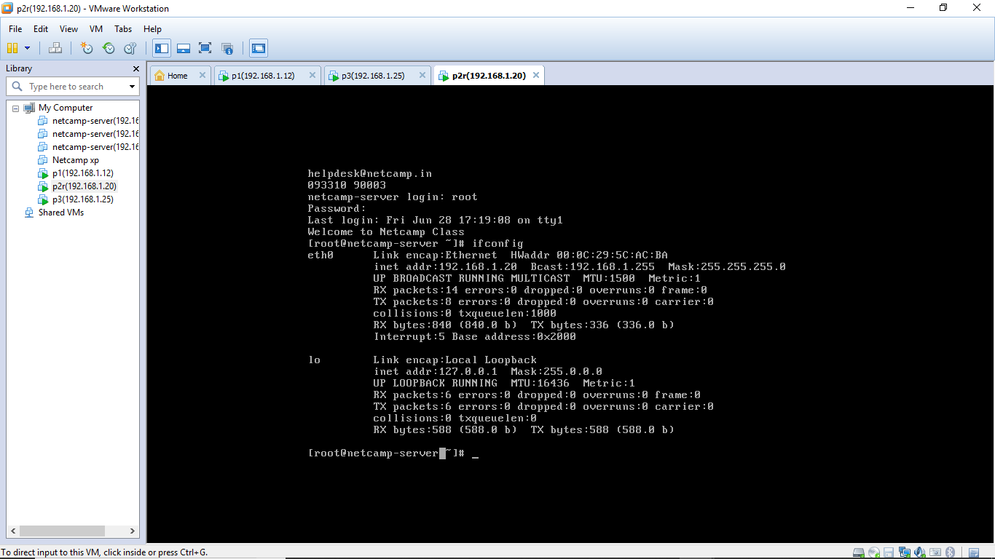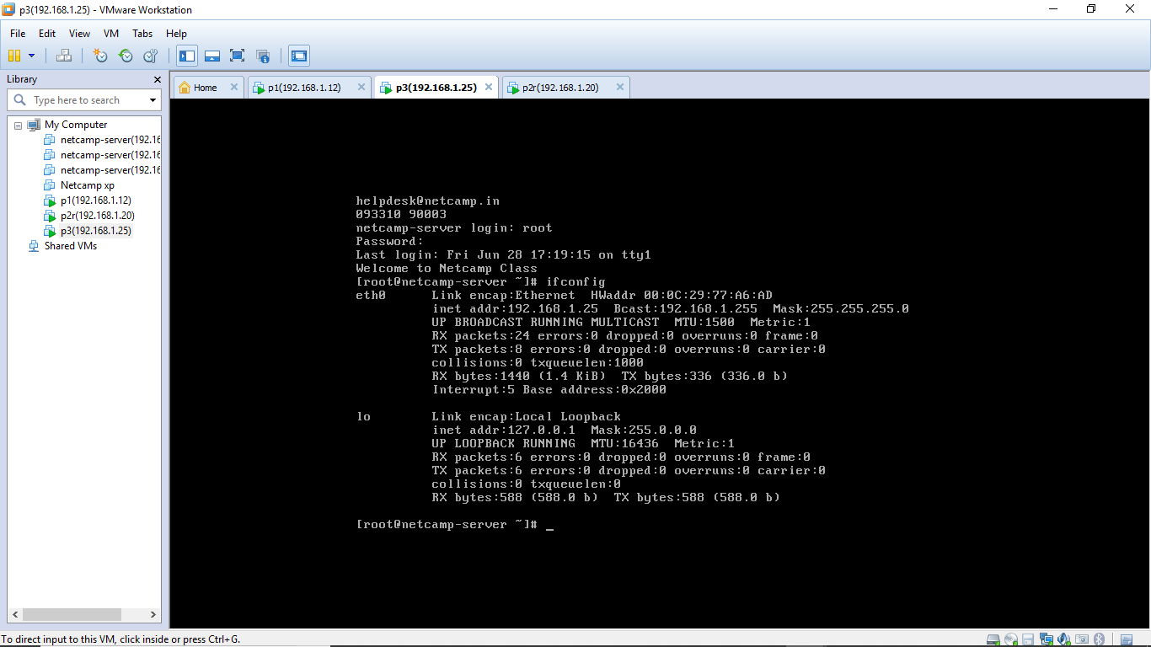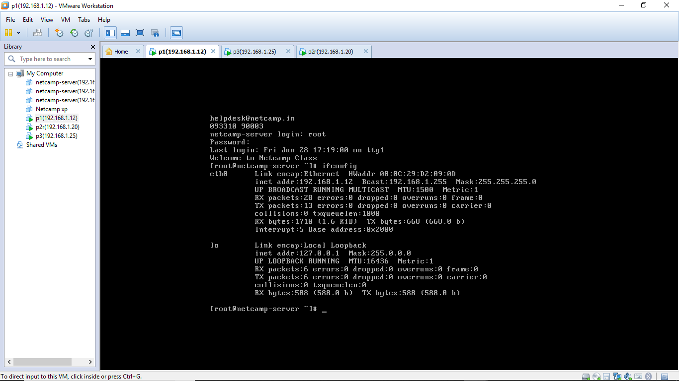

**DNS Setup :-**

Now, By default Webmin works on Port number 10000 , Since our DNS server’s ip is 192.168.1.100.

So to make any changes with the server(for example , to host something on web server , NFS,DHCP,SAMBA etc.) One easy way to configure everything is by using Webmin.

In order to open webmin one must enter the command 192.168.1.100:10000 in the web browser (which is DNS server’s ip + port number of Webmin).

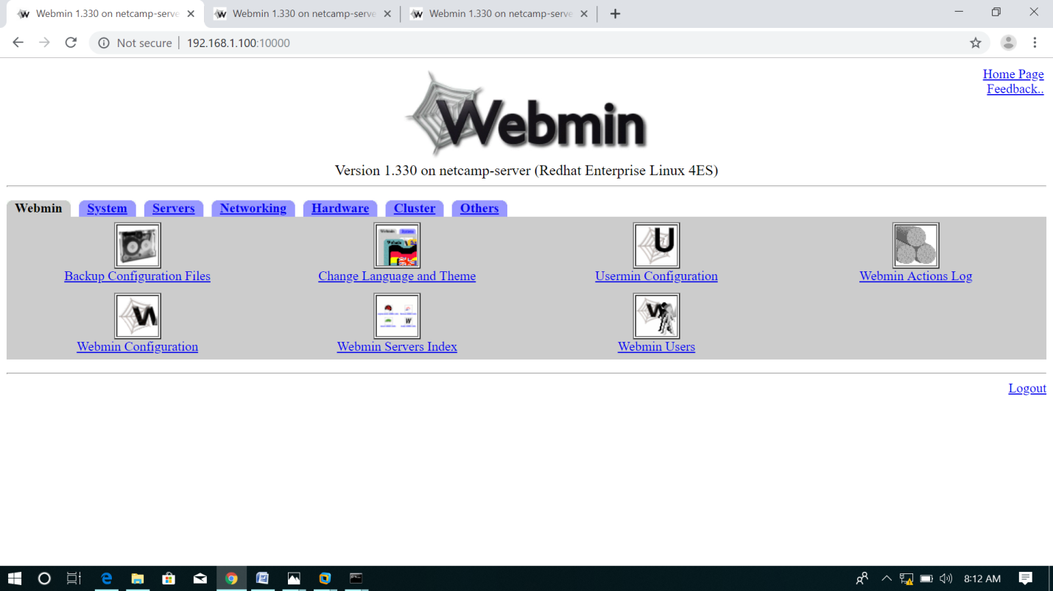

Once Webmin Index opens , one must login as root user in order to make any changes . After this, various tabs opens in the Webmin Index such as Webmin , System , Hardware , Networking etc .

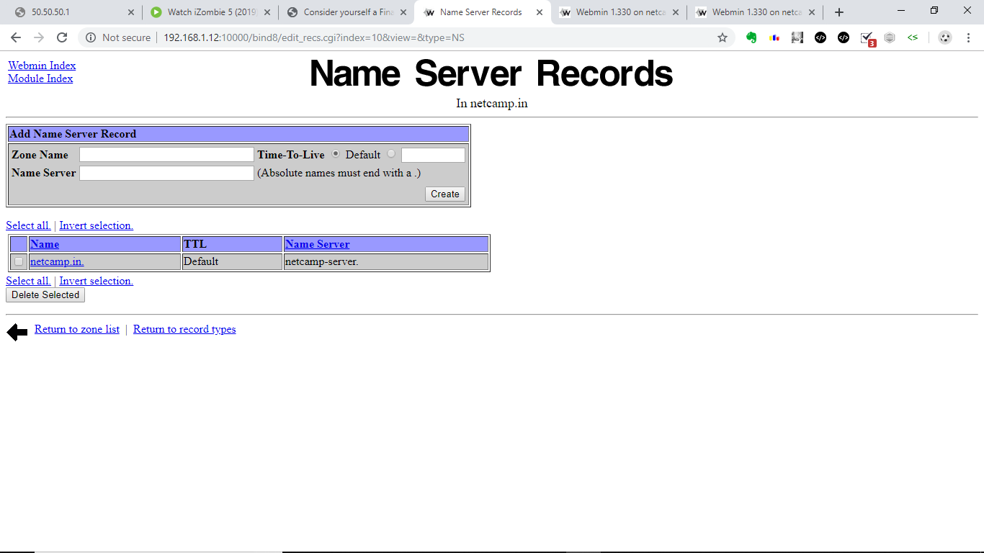

Then we open servers tab and in the servers tab there is a option named as BIND DNS server . After this we must open create master zone and set the domain name as netcamp.in and assign the email address .After creating the master zone , one must add three address records one for netcamp.in ( IP - 192.168.1.20) , 2nd one is [www.netcamp.in (](http://www.netcamp.in() IP-192.168.1.20 which is same as that for netcamp.in) & the 3rd one is for mail.netcamp.in( IP - 192.168.1.25 ) as shown in the next page. This is because 192.168.1.20 would be our webserver and 192.168.1.25 would be our mail server.

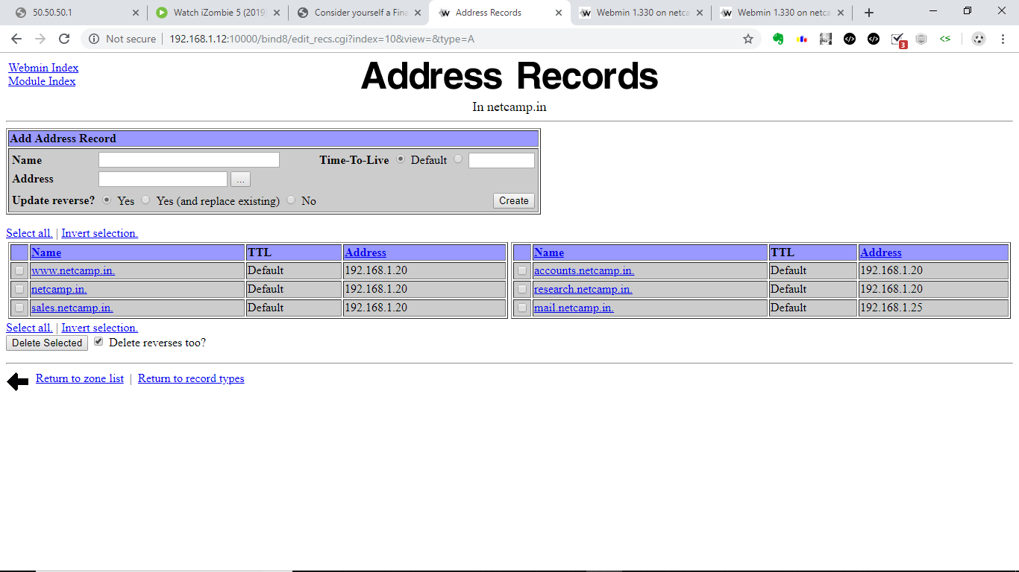

After this we must inform our DNS server regarding the Mail server so that it will be able to communicate with it.The name field is filled with the name “netcamp” and Mail server is “mail.netcamp.in”.

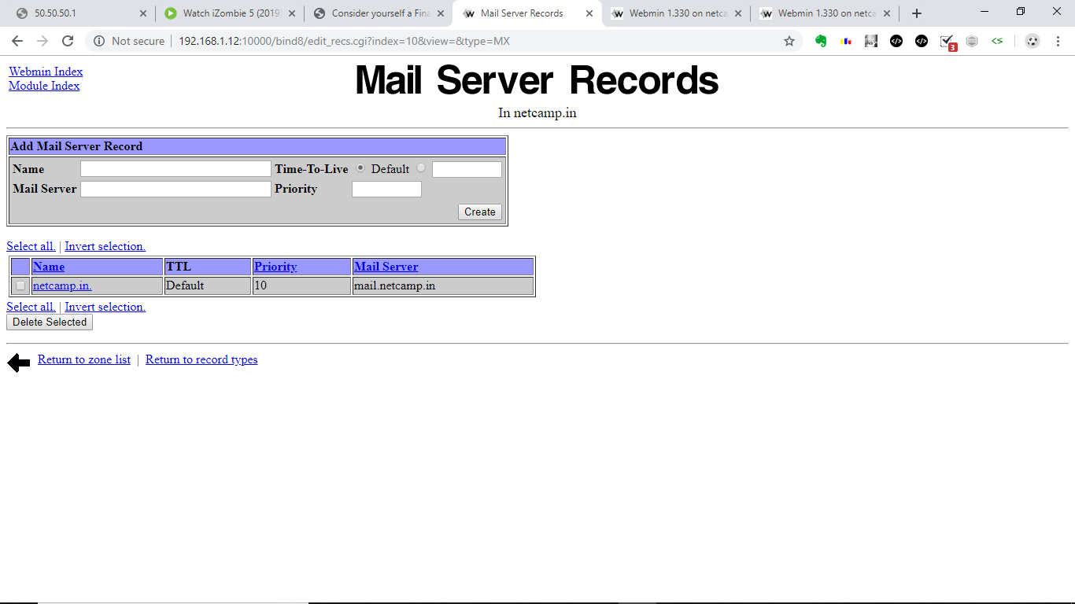

**Webserver Setup –**

We now telnet into our Webserver, give ourselves root privileges and then as required we create 4 folders in ‘/’ called webnetcamp (The docment root for the main website), websales, webresearch and webaccounts.(The document root folders for sales, R and D and accounts departments).

We then enter webmin of 1192.168.1.200, login as root and go to Servers -> Apache. Here we configure the server to handle name-based server request for netcamp.in, [www.netcamp.in](http://www.netcamp.in), sales.netcamp.in, research.netcamp.in and accounts.netcamp.in.

The final configuration is shown in the image on the next page.

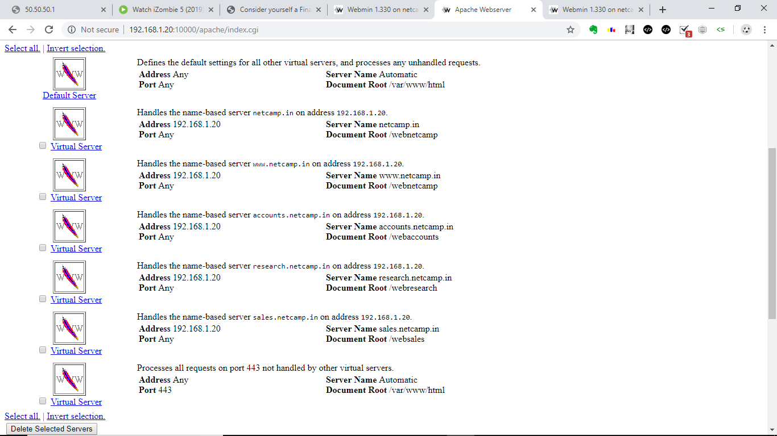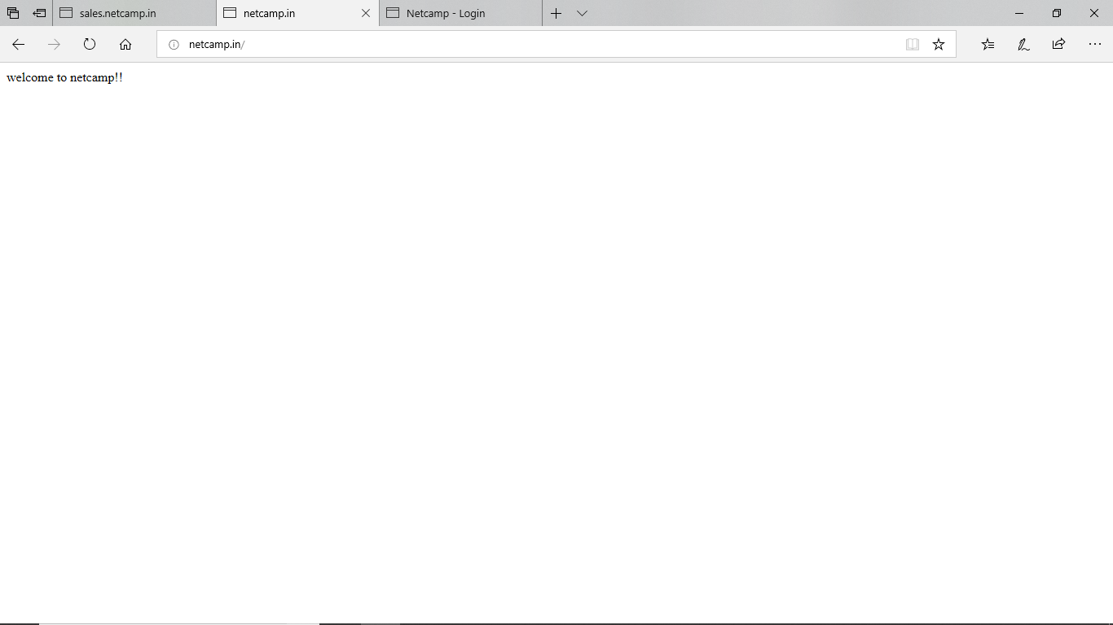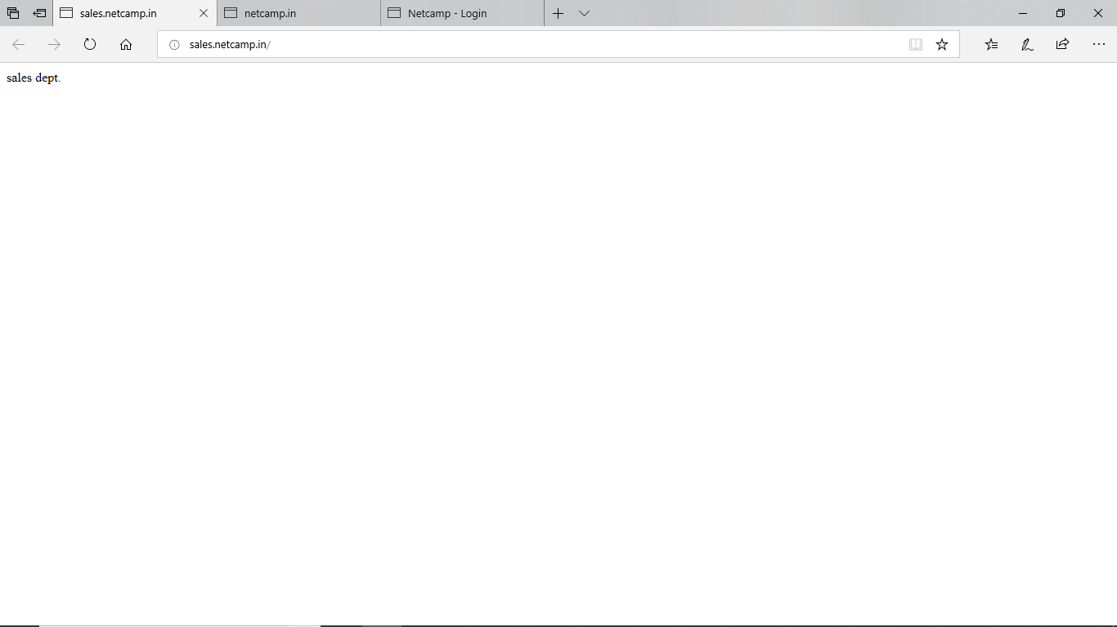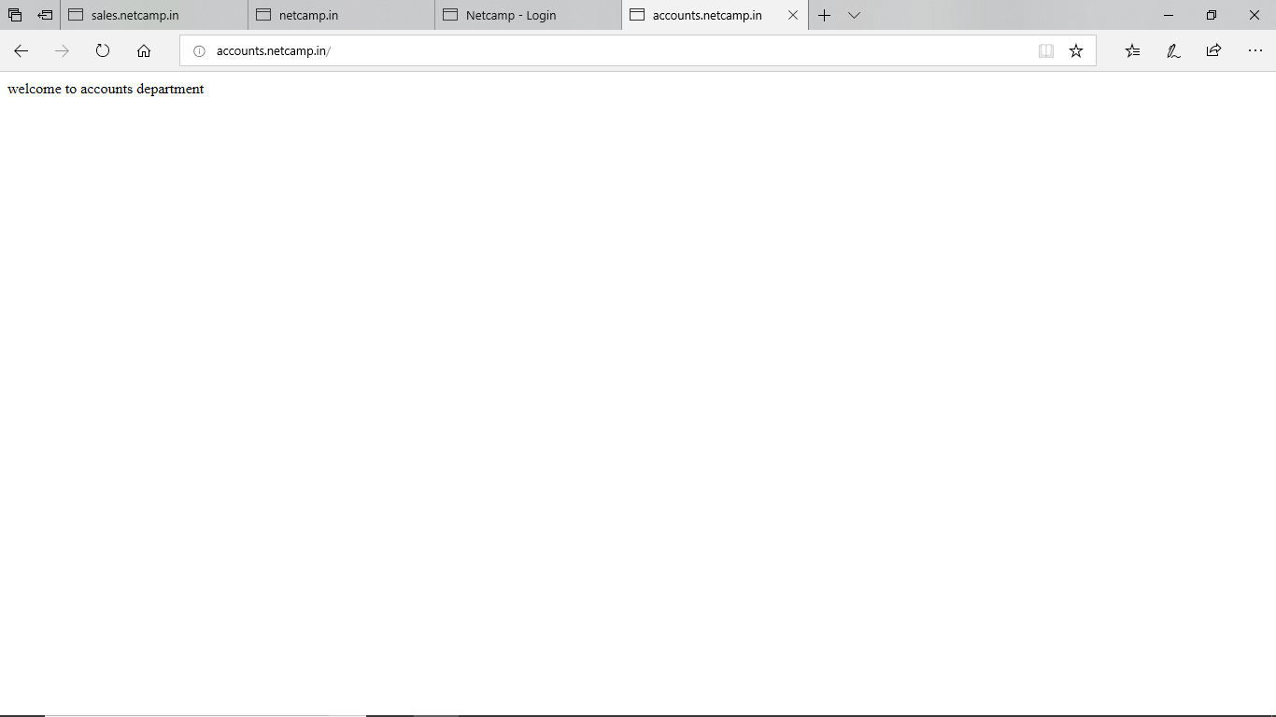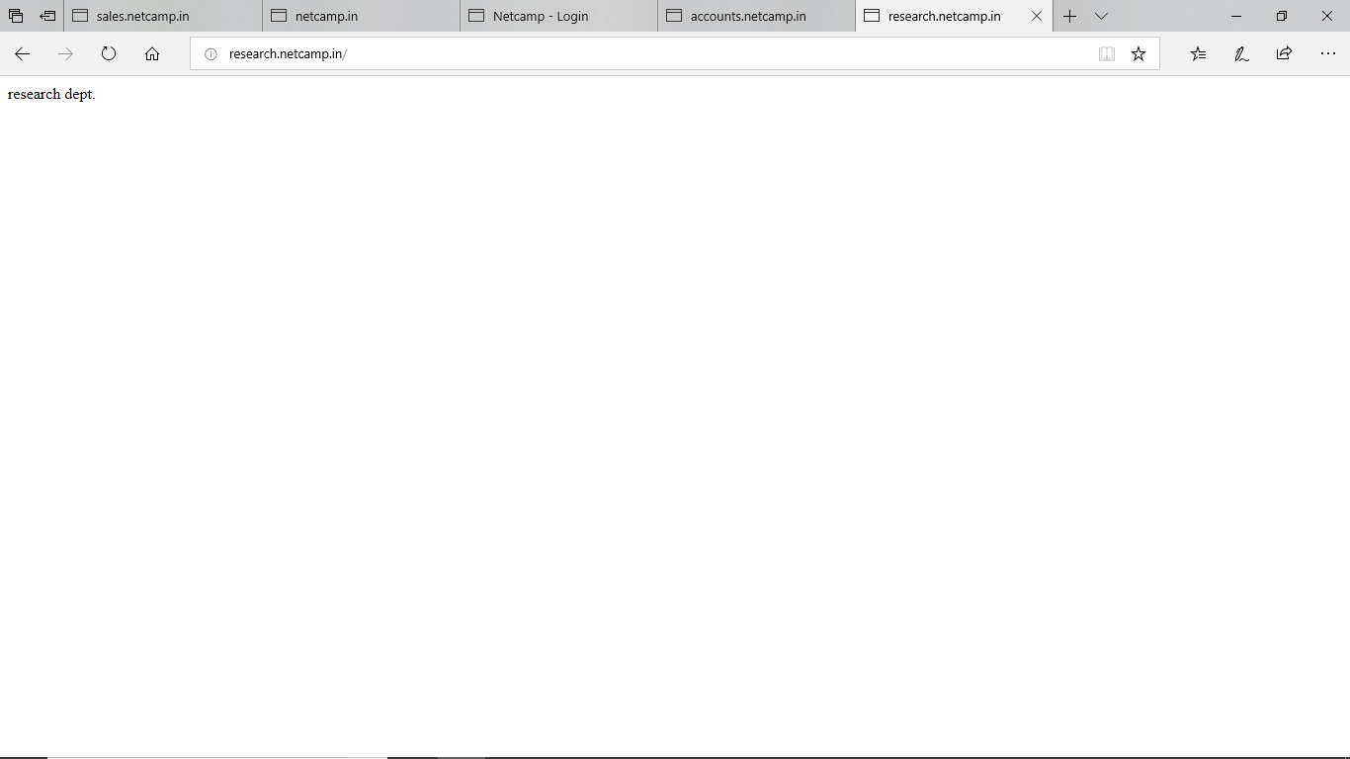

**Mail Server Setup :-**

We next open webmin of our 3rd Server which is going to be our mail server. Here we first need to host the mail server so go to Servers -> Apache.

We host from our 3rd server squirrelmail. **SquirrelMail** is a project that provides both a [web-based email client](https://en.wikipedia.org/wiki/Webmail) and a [proxy server](https://en.wikipedia.org/wiki/Proxy_server) for the [IMAP](https://en.wikipedia.org/wiki/IMAP) protocol.

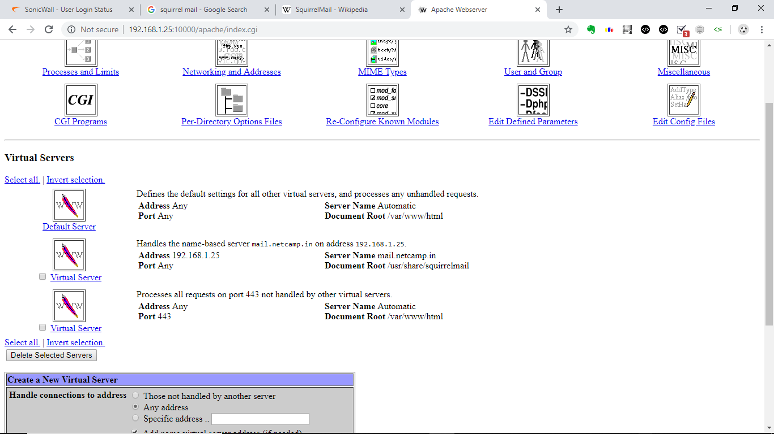

Next we need to configure the network so that it knows that is is the mail server and listen’s to request made to mail.netcamp.in or @netcamp.in. This is done by adding netcamp.in and mail.netcamp.in to the host address list as shown.

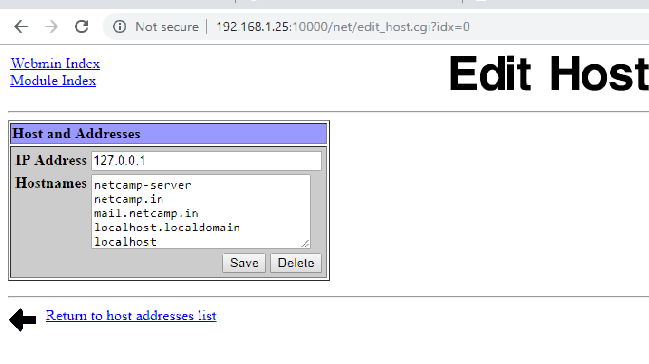

After this , we configure the sendmail options and remove the localhost address since we are using our own localhost in order to host the things . After removing the localhost address which is 127.0.0.1. The SMTP will not check for the localhost address and sending mail within the local server will have a greater speed than with the previous sendmail configurations.

In the Local Domains , the sub-domains [www.company.in](http://www.company.in) and mail.company.in is added as shown and the settings are saved.

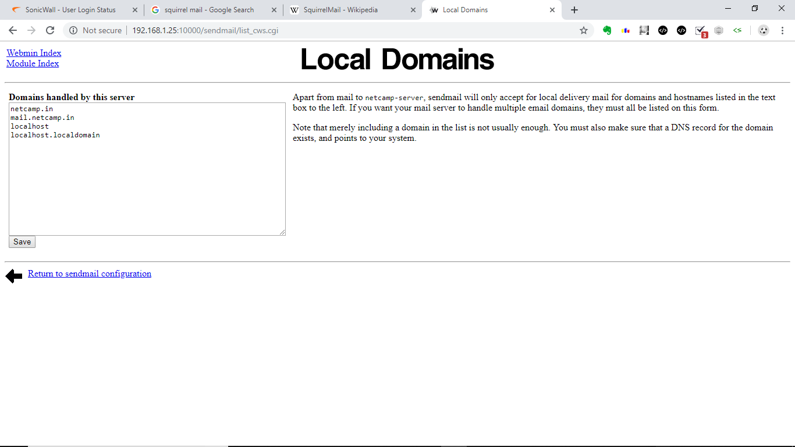

After this we must enable our DOVECOT IMAP/POP3 Server so that a user can read and download the mails one receives and then apply configuration .

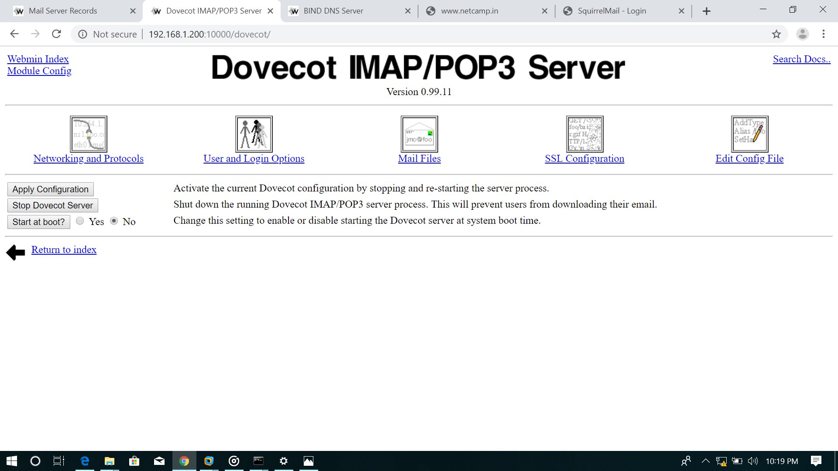

In the Networking and Protocols section ,there is a sub-section named

as server mail protocols where all the protocols namely **IMAP,POP3,IMAP(SSL),POP3(SSL)** is selected and saved according to the requirements of the send mail configurations.

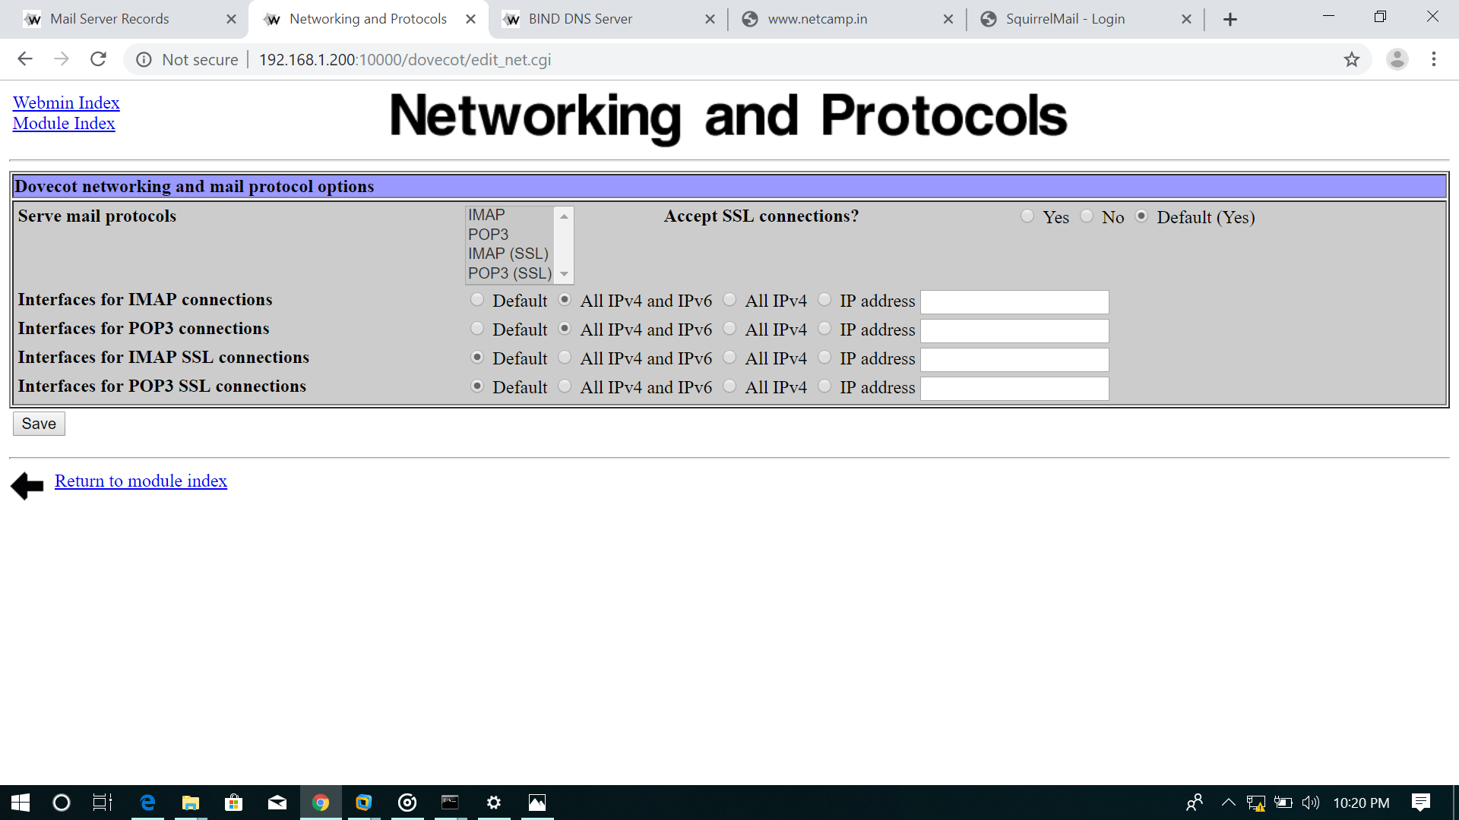

Next we go to /usr/share/squirrelmail/src to configure squirrel mail for our company. We change the .config files so that the logo and company name is ours. We can also change the login.php files to customize the login page. We customized the page as shown.

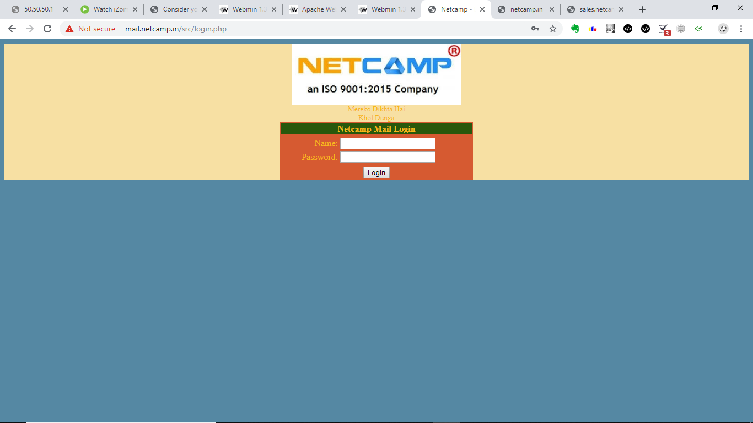

Sign in as user1, click on options -> personal information and add the following.

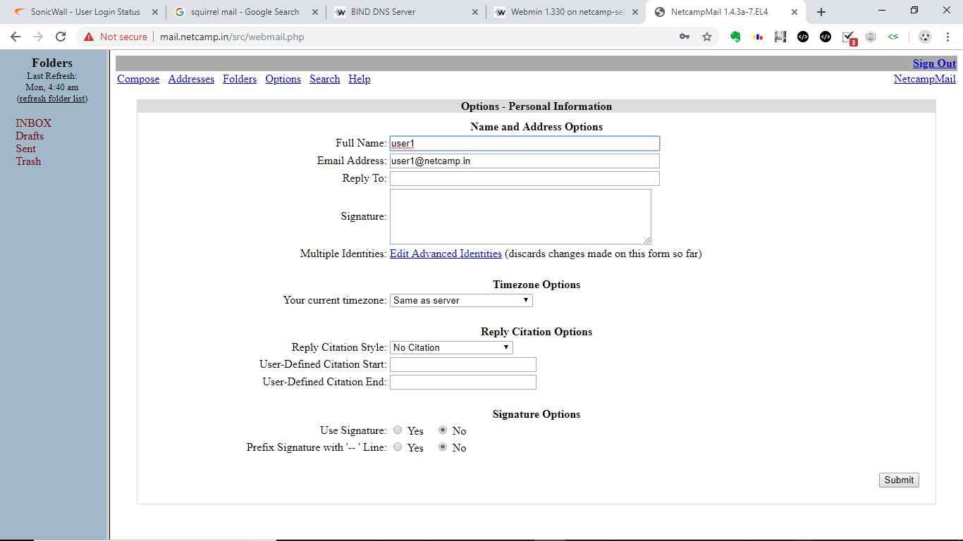

Similary for user2, now user1 and user 2 are configured. We will try sending mail from user 2 to user1, so click on compose next.

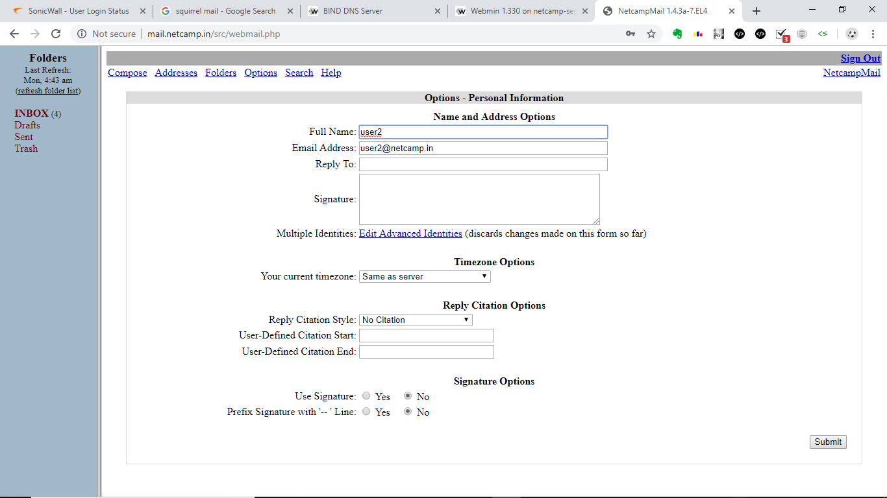

A sample mail, we will login as user1 as check if mail has been received.

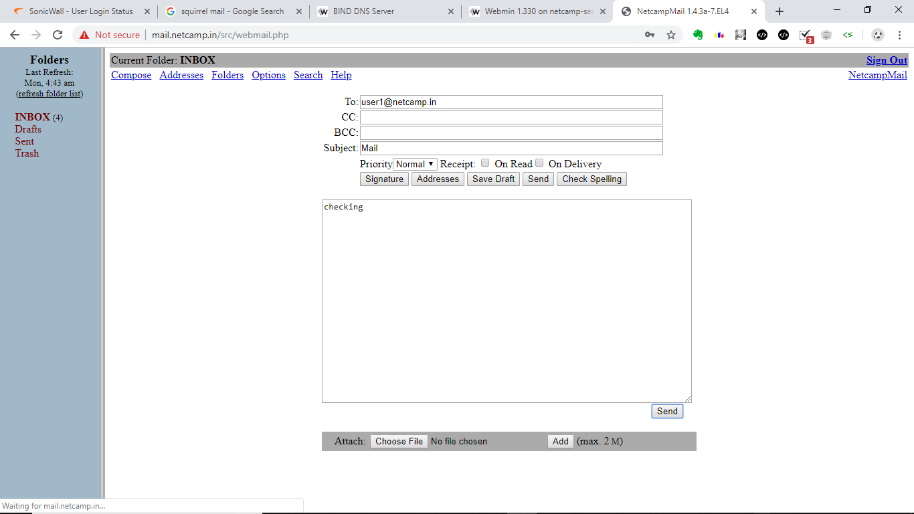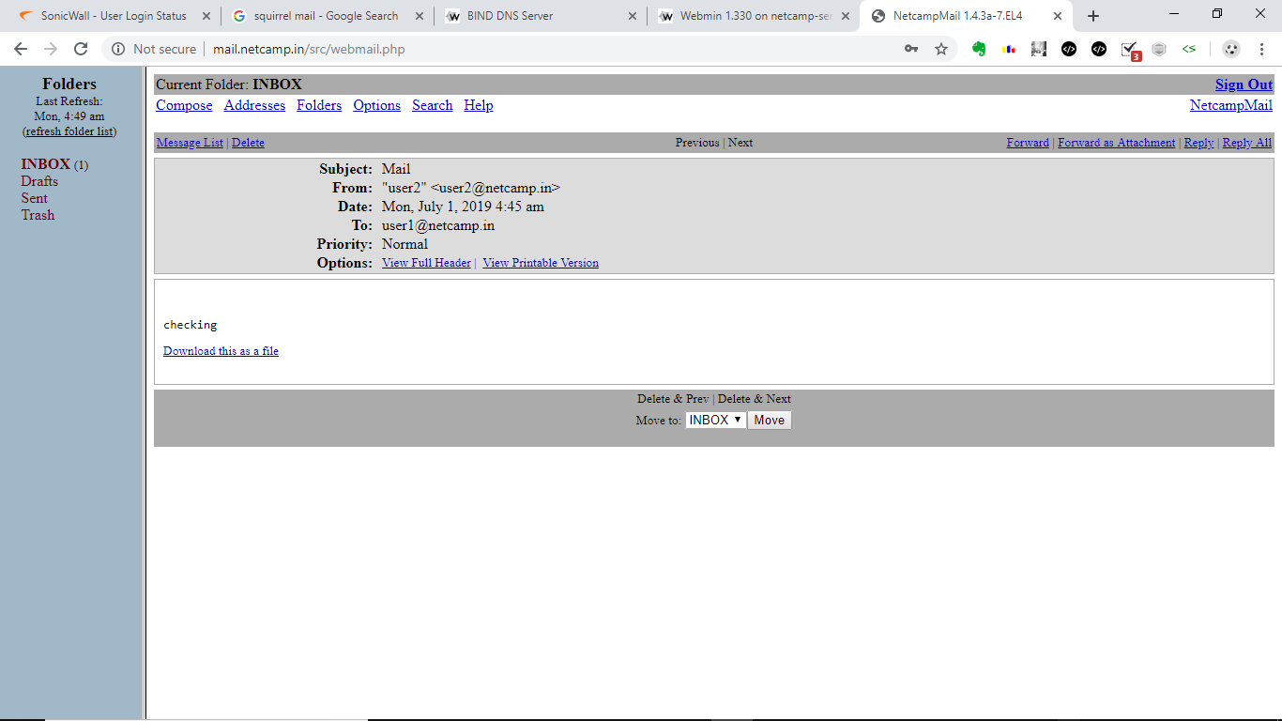

Clicking on download allows us to download the mail.

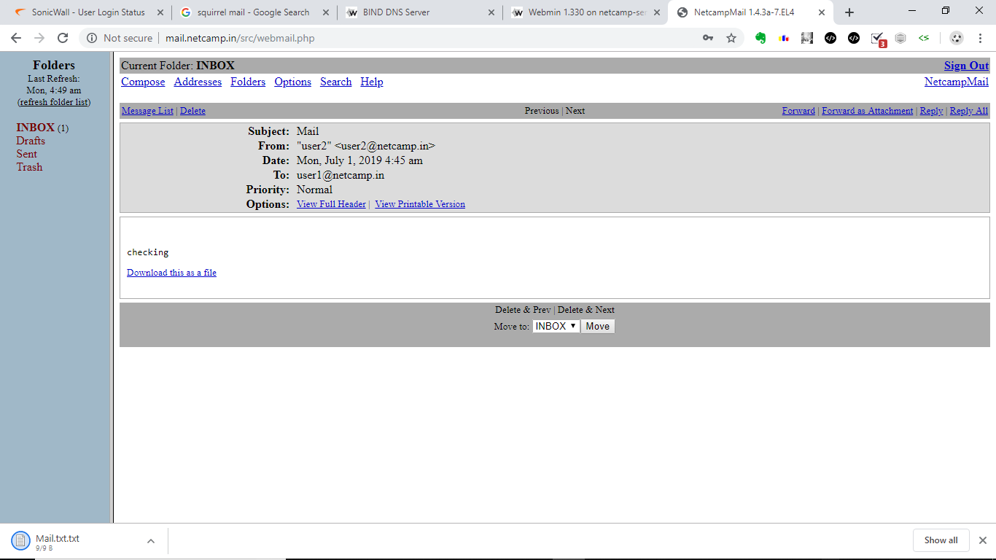

**DHCP Setup:-**

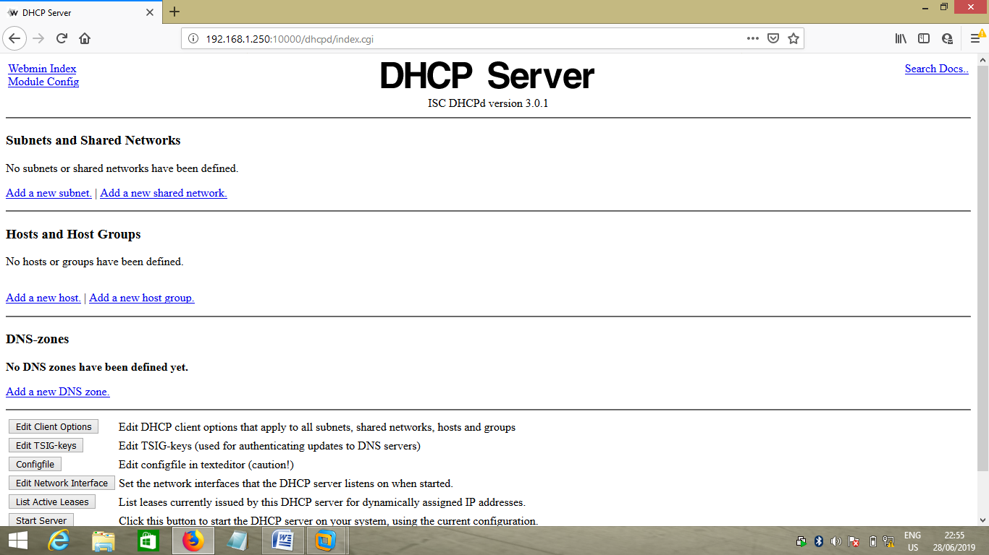

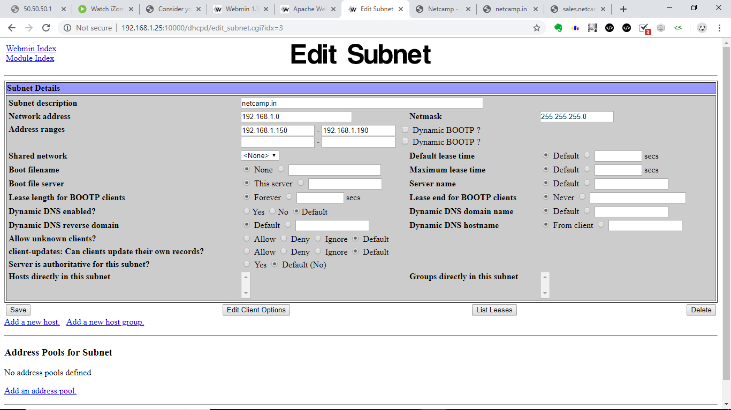

We would still need to add dns and gateway and then can start our server. The mail server has now been configured for being dhcp server.

**Samba Share configurations and Linux File permissions :-**

We create 3 directories for the 3 department’s namely sales, accounts and randd.

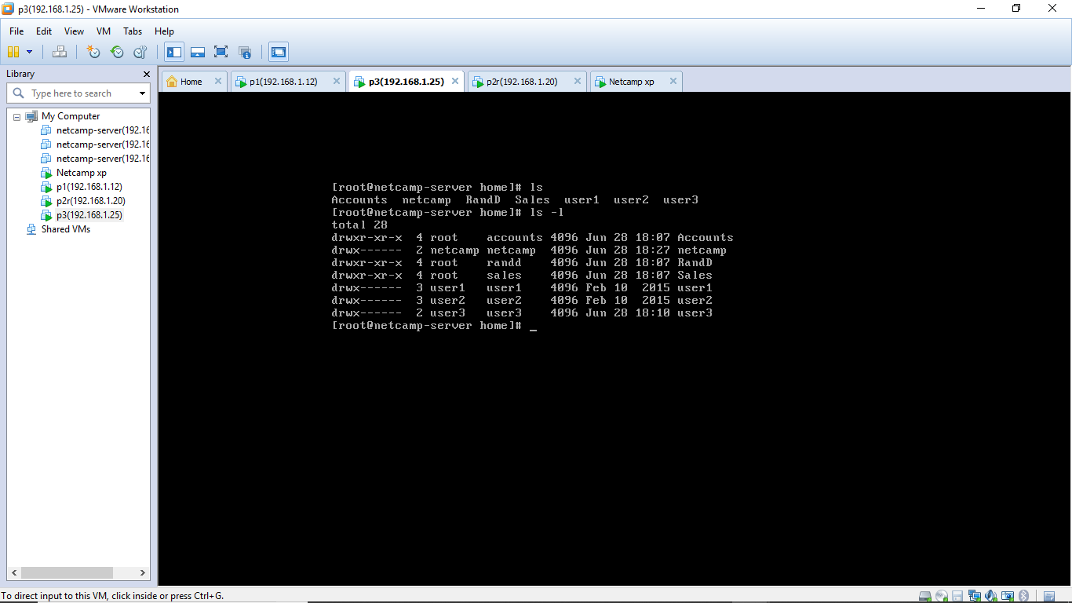

Next we set permissions as shown below and create and add groups as shown.

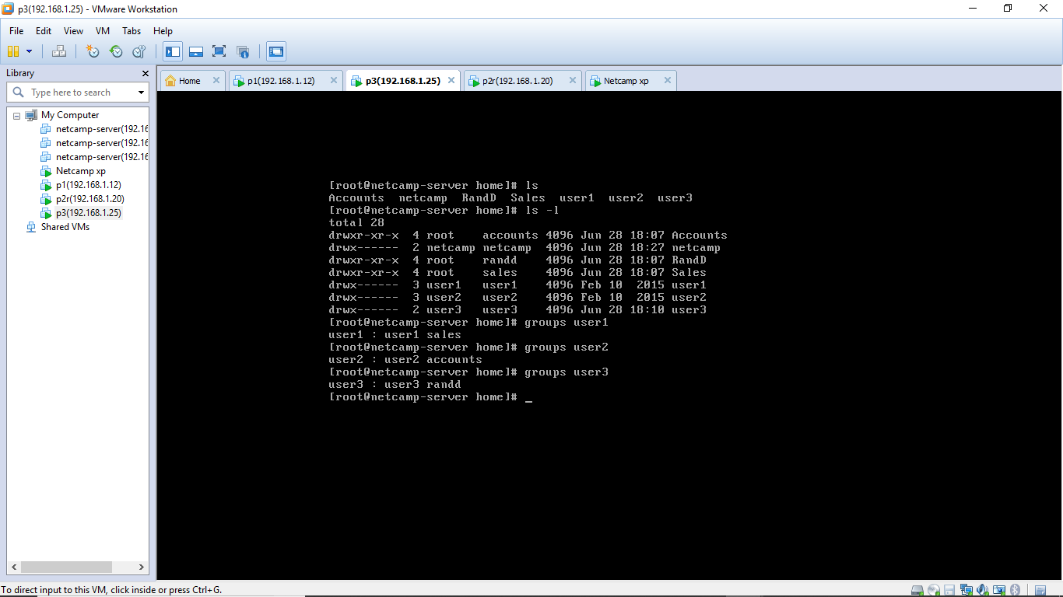

From the 3 users we have user1 who belongs to the sales department, user2 who belongs to the accounts department and user who belongs to the R and D. The root refers to the chairman of the company.

**SAMBA Software Description**

Samba is a free software re-implementation of the SMB networking protocol, and was originally developed by Andrew Tridgell. Samba provides file and print services for various Microsoft Windows clients and can integrate with a Microsoft Windows Server domain, either as a Domain Controller (DC) or as a domain member. As of version 4, it supports Active Directory and Microsoft Windows NT domains.

Samba runs on most Unix, OpenVMS and Unix-like systems, such as Linux, Solaris, AIX and the BSD variants, including Apple's macOS Server, and macOS client (Mac OS X 10.2 and greater). Samba is standard on nearly all distributions of Linux and is commonly included as a basic system service on other Unix-based operating systems as well. Samba is released under the terms of the GNU General Public License. The name Samba comes from SMB (Server Message Block), the name of the standard protocol used by the Microsoft Windows network file system.

Samba allows file and print sharing between computers running Microsoft Windows and computers running Unix. It is an implementation of dozens of services and a dozen protocols, including:

* NetBIOS over TCP/IP (NBT)
* SMB (known as CIFS in some versions)
* DCE/RPC or more specifically, MSRPC, the Network Neighborhood suite of protocols
* A WINS server also known as a NetBIOS Name Server (NBNS)
* The NT Domain suite of protocols which includes NT Domain Logons
* Security Account Manager (SAM) database
* Local Security Authority (LSA) service

We next go to the webmin again and go the samba windows file sharing. We configure here to add user1, user2 and user3 by clicking on convert linux user to samba user.

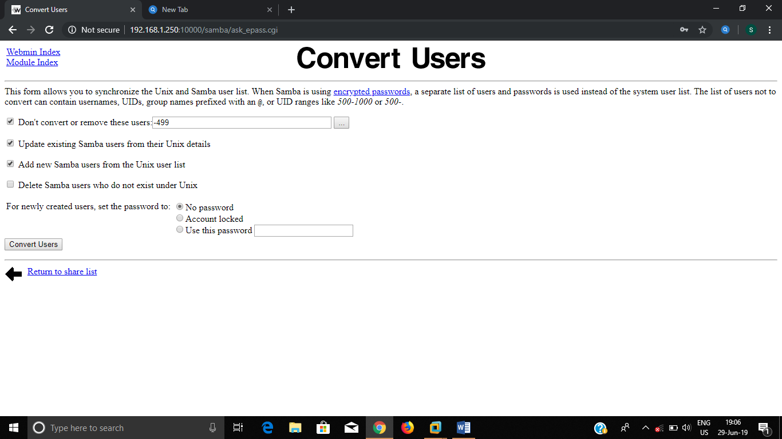

Next we edit user settings and change the password.

Next we add directory to be shared as /home. This automatically allows for sharing of the 3 sub-directories Sales, R and D and Accounts.

Changing the security access to allow for write permission completes the setup process.

**Verification :-**

We login from a client machine and run the command \\192.168.1.25 and then login. We can now see the contents of the home directory.

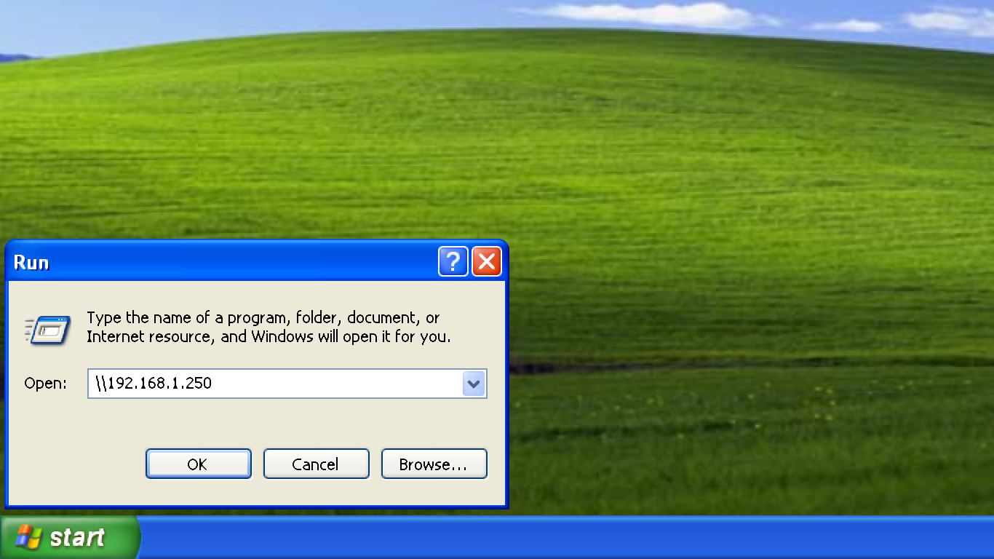

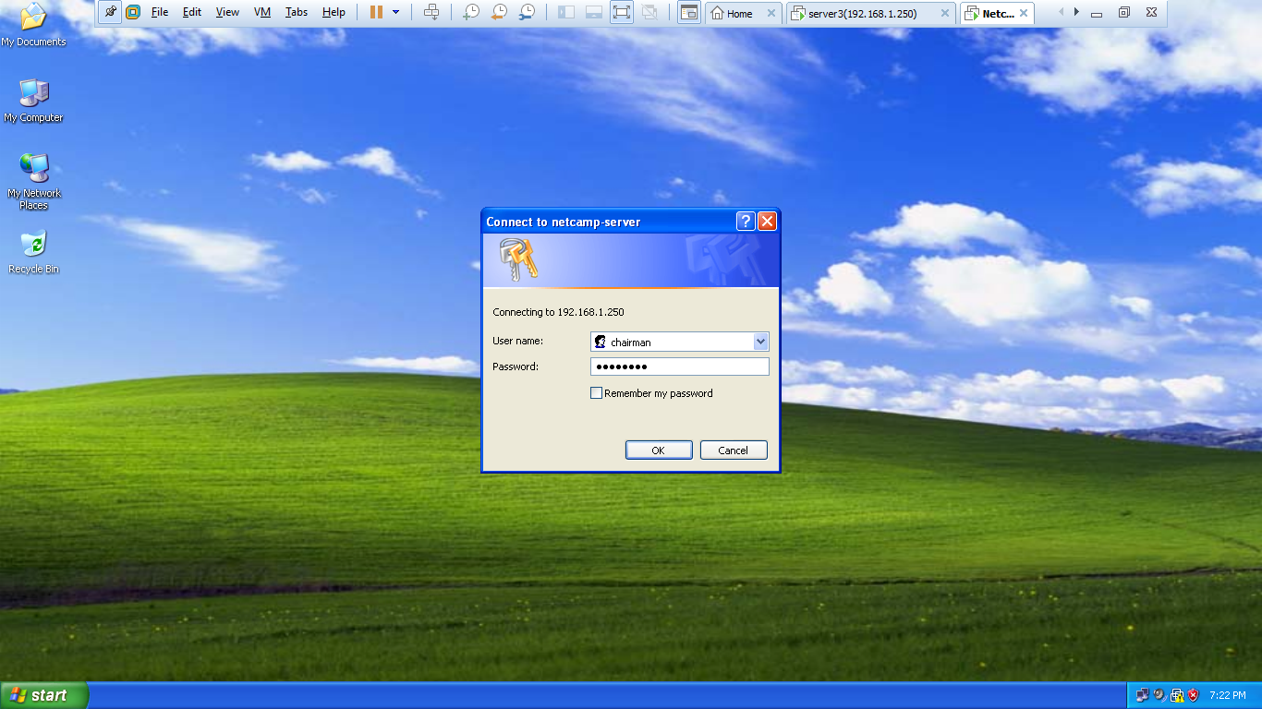

When trying to access the \Sales\data or \randd\driver folders we get the following. This confirms that no one from accounts department can access the data or driver folders of other departments and vice versa.

Next when we access the accounts folder we are allower to do so as User2 belongs to the accounts dept, that is has been added to accounts group.

Thus in our company to configure new users we just need to change their group to the department they belong.

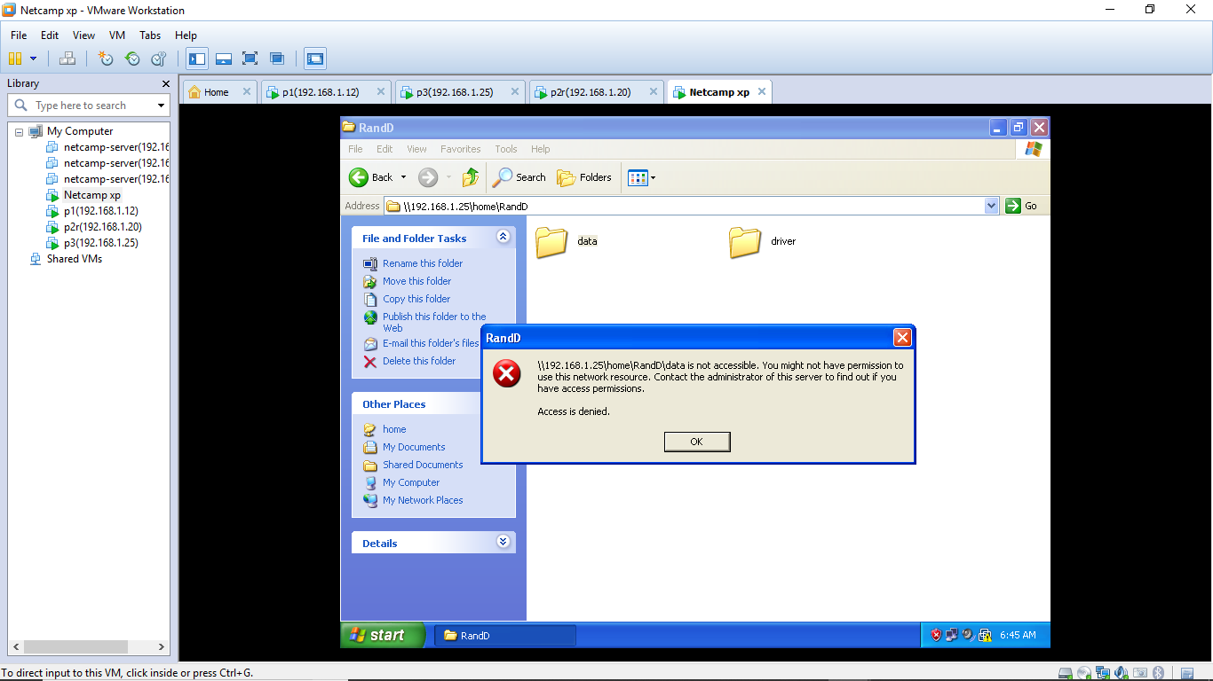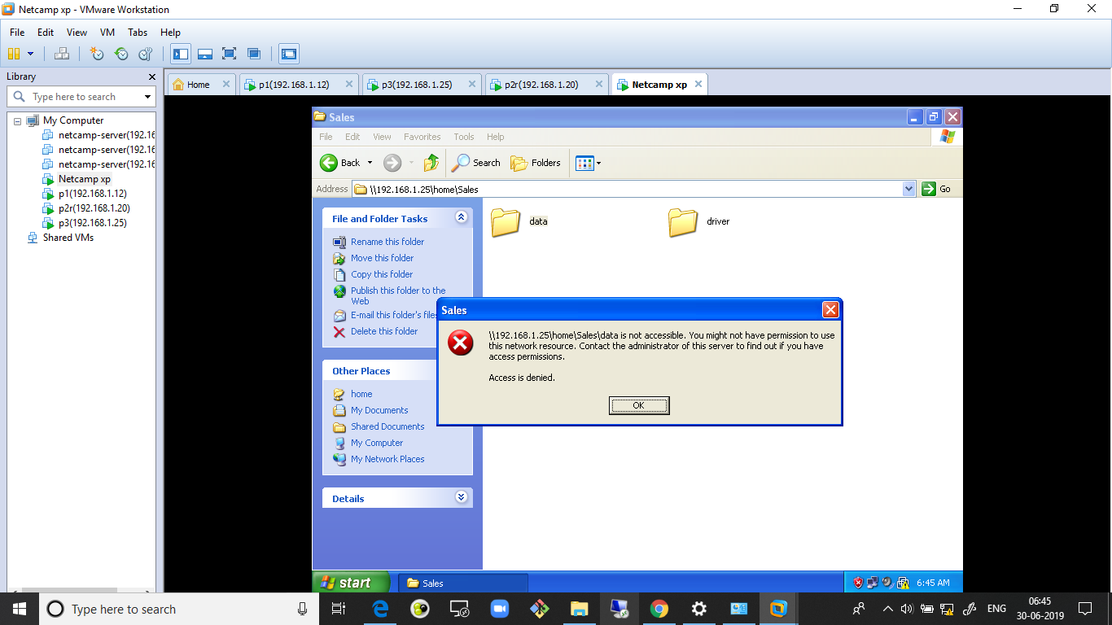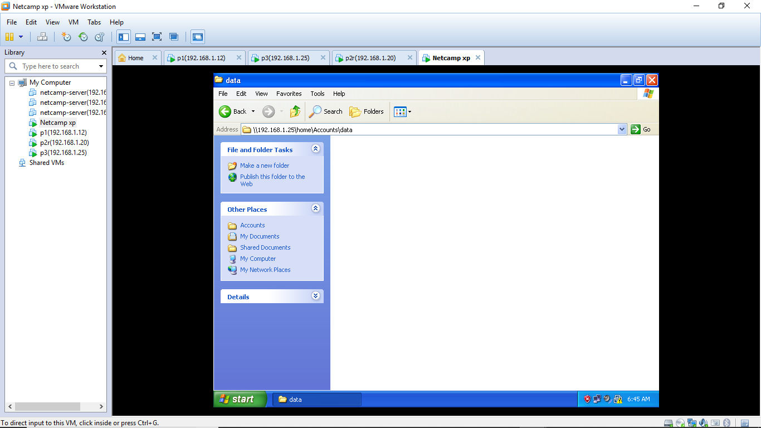

**FireWall Settings :-**

**We are blocking all ip’s from outside the range of our company’s employee’s ip range.**

